Development of ‘LightMeCup’ Prototypes Using Entry-Level 3D Printers

Soo Ji Choi  Department of Art & Technology, Bachelor of Fine Arts, School of the Art Institute of Chicago, 36 S Wabash. Chicago, IL 60603, USA.  sooart0504@gmail.com | Seung Ryul Lee  Department of Visual Communication Design, Bachelor of Fine Arts, School of the Art Institute of Chicago, 36 S. Wabash. Chicago, IL 60603, USA.  seng93727@icloud.com | Myoung Ju Won  Industry-Academy Cooperation, Sangmyung University, 20 Hongjimun 2-gil, Jongno-gu, Seoul, Korea.  dnjsaudwn@naver.com

Abstract
The purpose of this study was to develop a multi-sensory product using an entry-level 3D printer. This study developed a prototype of the product, which functions as a tumbler type cup while being responsive to the environmental sound and motion of the cup. A survey for usability test was performed in questionnaires by 20 subjects on a 5-point Likert scale. The product has been designed and modeled by the Autodesk Fusion 360 software and printed on an entry-level 3D printer 3DISON PRO with low-cost PLA filaments. The design of the product was made based on usability and convenience, and contains three main detachable parts of a cap, body, and support (sensor case).
Keyword
3D Printing, Multi-sensory, Modeling

Introduction
3D printing technology development and commercialization are increasing worldwide. New products are being developed using 3D printing technology in various fields such as medical, architecture, industrial products and fashion. With the recent development of relatively inexpensive 3D printers, it has become possible for the public to make products using entry-level 3D printers. The approach of making products using 3D printers is a new era of change for researching new forms and producing experimental products. Recognizing the problem of mass production of random replicas and sharing different product development and production processes are required. Therefore, in this study, we have selected an industrial product as our design target, which have high practical utilization among user who can use model directly or commercialize using 3D printer. The design product created in this study is defined as ‘LightMeCup’.

LightMeCup is a tumbler type cup that is used frequently in everyday life and at the same time, it is a lighting object that reacts to the environment and the user’s interaction. The device explores the interaction between people and objects (home applications and devices) through a development of multi-sensory device that responds to the user and the environment. The utilization possibilities of the responsive technology were investigated as well as how interactive design decisions influence the user experience. We ultimately tried to induce positive emotion and entertaining experience to the users in an everyday setting, while also having a multi-function. Studies show that eliciting positive affect through user experience not only increases the likelihood of frequent use of the device itself but also enhances the overall mood of the user and the environment (Desmet & Hekkert, 2007; Hassenzahl et al., 2010; Sutcliffe & Hart, 2017). Moreover, it is designed for practical use by outputting with a 3D printing filament that is harmless to the body (FDA compliant filament). The scope of this project extends beyond our reactive light technology for other possible applications mentioned in the conclusion.

LightMeCup Prototypes Overview

Design Method
To include a holistic experience of human-computer interaction (HCI), three core principles were selected as the basis of designing the product:
1. Usability and Convenience from UX Design
2. Multi-sensory Feedback from Engineering
3. Affective Functioning from Psychology

Inputs and Outputs
LightMeCup is developed to induce an affective interaction with sound and motion reactive light. It also has a multi-functionality as a desk light as well as a tumbler cup. The loudness and frequency of sound as well as the tilt and acceleration of the device is received, and a feedback is provided through RGB LED light.

Development

Electronic Components
Electronic components used to develop the LightMeCup are listed below in Table 1. Arduino Nano was used as the main board. It connected with microphone sound sensor and gyroscope sensor to receive information on the environmental sound and motion by user interaction. LED light in RGB colors was emitted in response to the loudness and acceleration of the cup. Battery charging module and a lithium battery was included for wireless and continuous use. Likewise, on and off power switch was installed at the bottom of the cup.
Table 1. Electronic Components
Name | Function
Arduino Nano | The main board for input and output control
Microphone Sound Sensor | Receive the environmental sound and send the data to the Arduino Nano
Gyroscope Sensor | Receive the acceleration and tilt of the device and send the data to the Arduino Nano
RGB LED Ring Light | Emit reactive light that changes its colors based on the sound and motion data received
Battery Charging Module | Charge the lithium battery for reuse
Lithium Battery | Power the device wirelessly during use
Locking On/Off Switch | Control the power sent to all of the components from the lithium battery

Design and Measurements

The LightMeCup prototype examined the basic units of the existing tumbler type and beverage shape sizes, and performed a Focus Group Discussion (FGD) to find the optimal size. Finally, the most suitable size (74.8mmⅹ74.8mmⅹ191mm) and form for maximum grip comfort during drinking interaction was reflected in the design. In addition, the sensor module is designed to be placed at a minimum height. The thickness of the model body was tested at 5mm, 3mm and 1.5mm respectively and selected 1.5mm as the final thickness for the maximum output of the light. Detailed measurements are shown in Fig. 1.
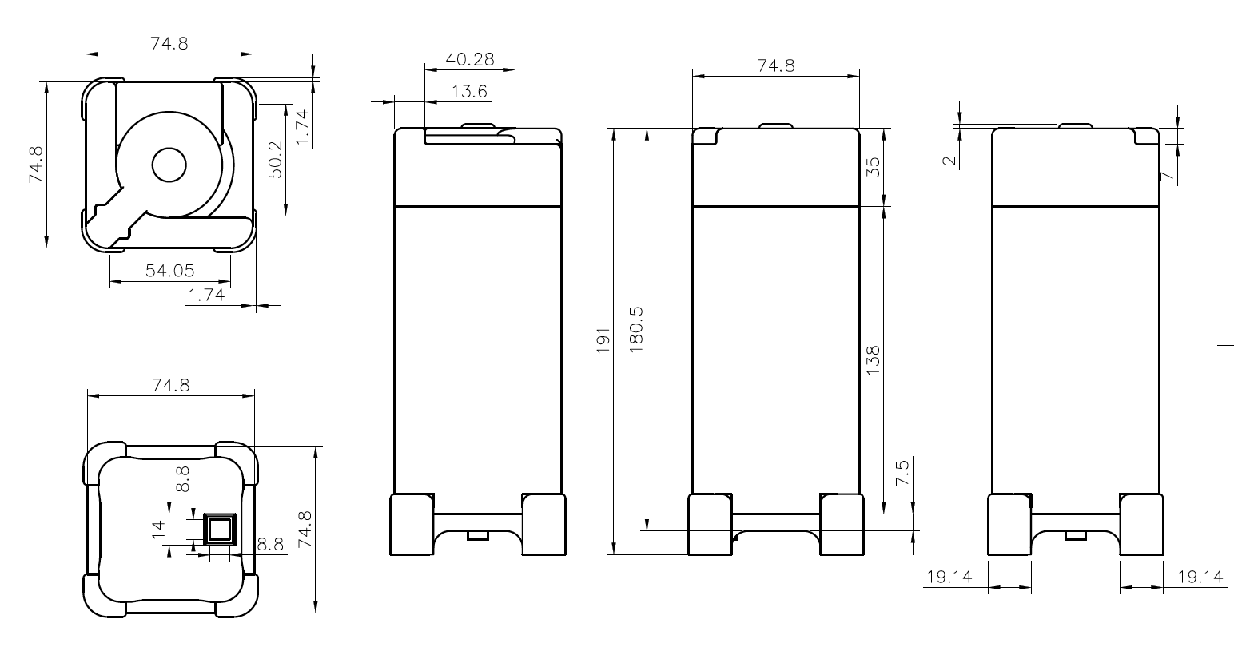
Figure 1 LightMeCup Measurements

Modeling and 3D Printing
Autodesk Fusion 360 software was used as a modeling tool, and the first verification was carried out through a virtual simulation. The first prototype was output to a 3D printer and its shape, size and assembly was evaluated. We then upgraded the LightMeCup to reflect the necessary corrections in the sample output. For practical use, the prototype was designed to be made with FDA compliant 3D printing filament that is made of a material that is harmless to the human body and usable as a cup. Maker Food Safe filament and PETT filaments have been widely used as a FDA compliant materials. Relatively low cost PLA filament was used for the prototypes in this study. Description of the 3D Printing hardware, materials and settings are shown in Table 2. Output speed was 15 mm / s, Nozzle temperature was 210 ℃ and Heating bed was 110 ℃.

Table 2. 3D Printing Hardware and Materials
Name | Specifications
3DISON PRO  (3D Printing Hardware) | Frame Dimension: 511mmX402mmX570mm
3DISON PRO  (3D Printing Hardware) | Dual Extruder System
3DISON PRO  (3D Printing Hardware) | Shaft Thickness of X:8mm, Y & Z: 12mm
3DISON PRO  (3D Printing Hardware) | Input of 100 ~ 220v, 50/60 Hz
3DISON PRO  (3D Printing Hardware) | Output of 24v, 9.0A
Creator K Software | Object Infill of 50%
Creator K Software | Layer Height of 0.2mm
Creator K Software | Feedrate 20 mm/s
Creator K Software | Travel Feedrate 15 mm/s
Creator K Software | Print Temperature 210℃
Creator K Software | HeatBed Temperature 110℃
.4mm PLA Filaments | .4mm PLA filaments (clear, white, yellow and red) compatible to the 3DISON PRO

LightMeCup Usability Testing
A survey was performed to evaluate the usability of the prototype developed in this study. The questionnaires were evaluated by usability testing 20 subjects for one day who were either a frequent users of tumblers and table lights in daily life or subjects that were not frequent users (male 10, female 10, mean age 27.2±4.3). The questionnaire consists of PPP (product performance program) evaluation and research used in universal design products. The evaluation of PPP is based on consideration of equitable use, flexibility in use, simple and intuitive use, consideration for information transmission, prevention of accident and malfunction, minimization of physical burden, adequate size and space, seven main principles of care for durability and economy, the pursuit of quality and aesthetics, and the auxiliary principle of consideration for the human body and the environment, and can be applied flexibly according to the product to be evaluated (Ikeda, 2005). In addition, the respondents who did not respond sincerely in the questionnaire process were identified, and the inverted items were included to ensure the reliability of the measurement items. The subjects were rated on a 5-point Likert scale from a score of 7 “strongly agree” to 1 “strongly disagree”.
Table 3. Rendered Result of the Model
Front | Back | Right | Left
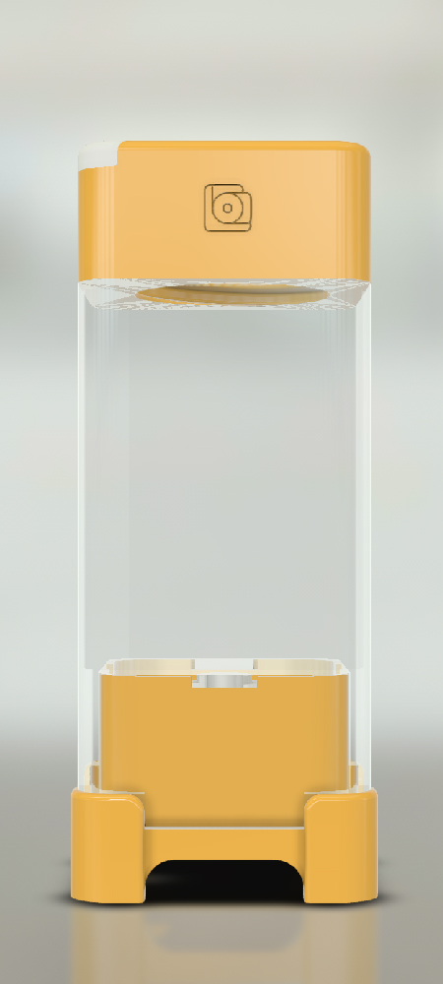 | 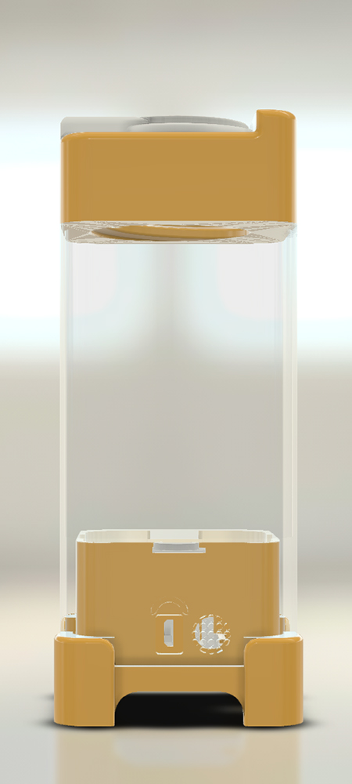 | 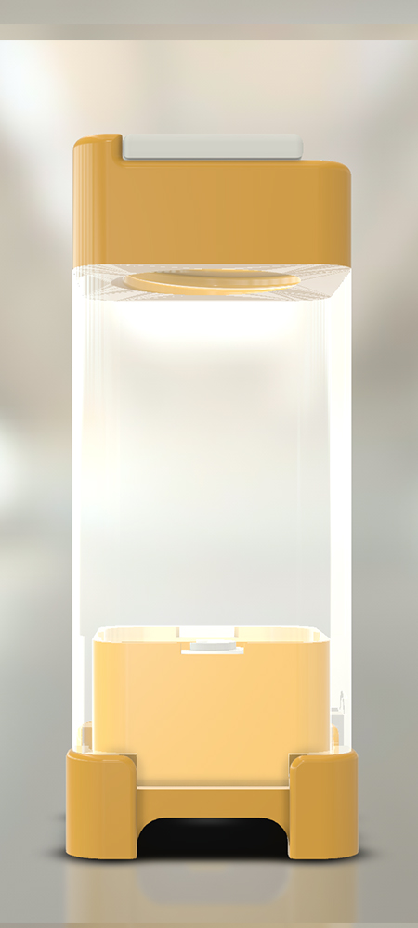 | 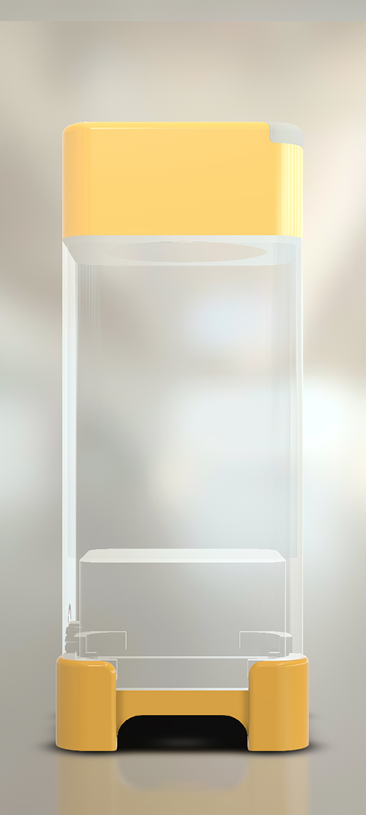
Perspective | Top | Bottom
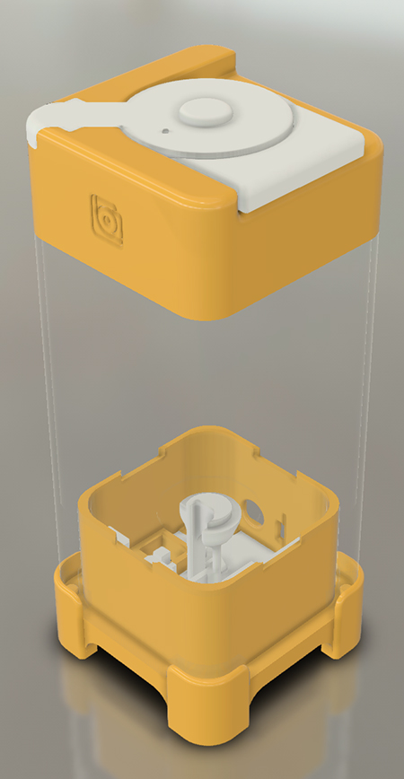 | 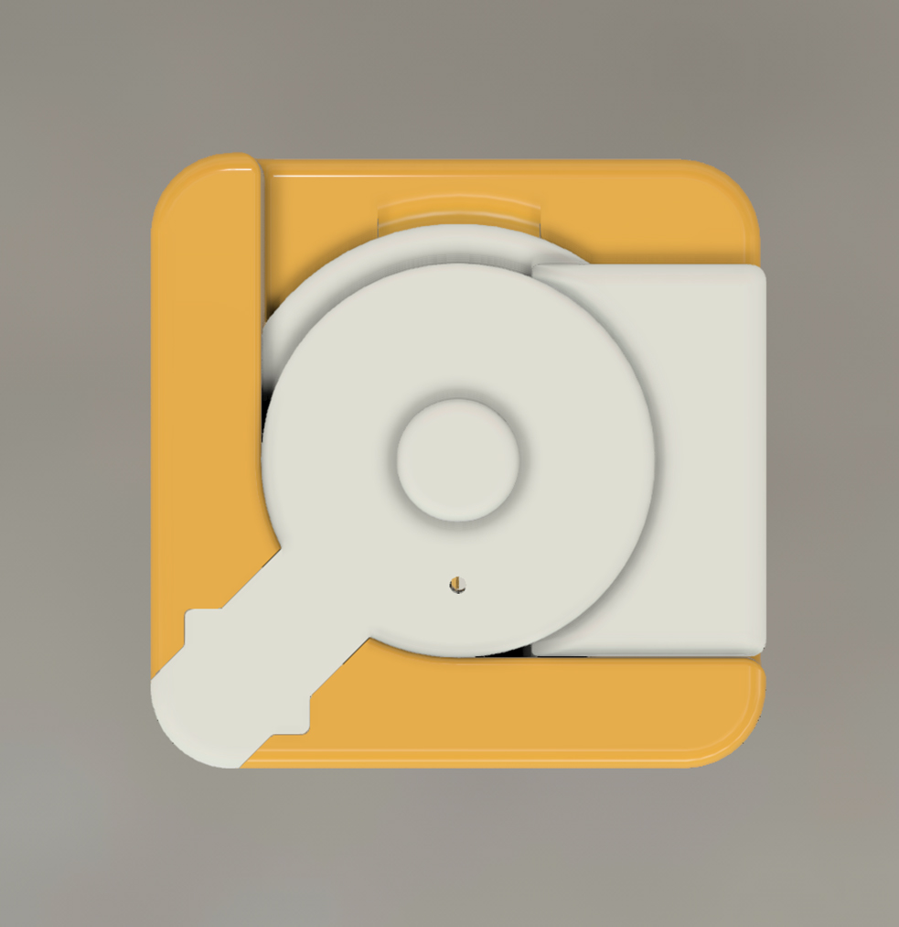 | 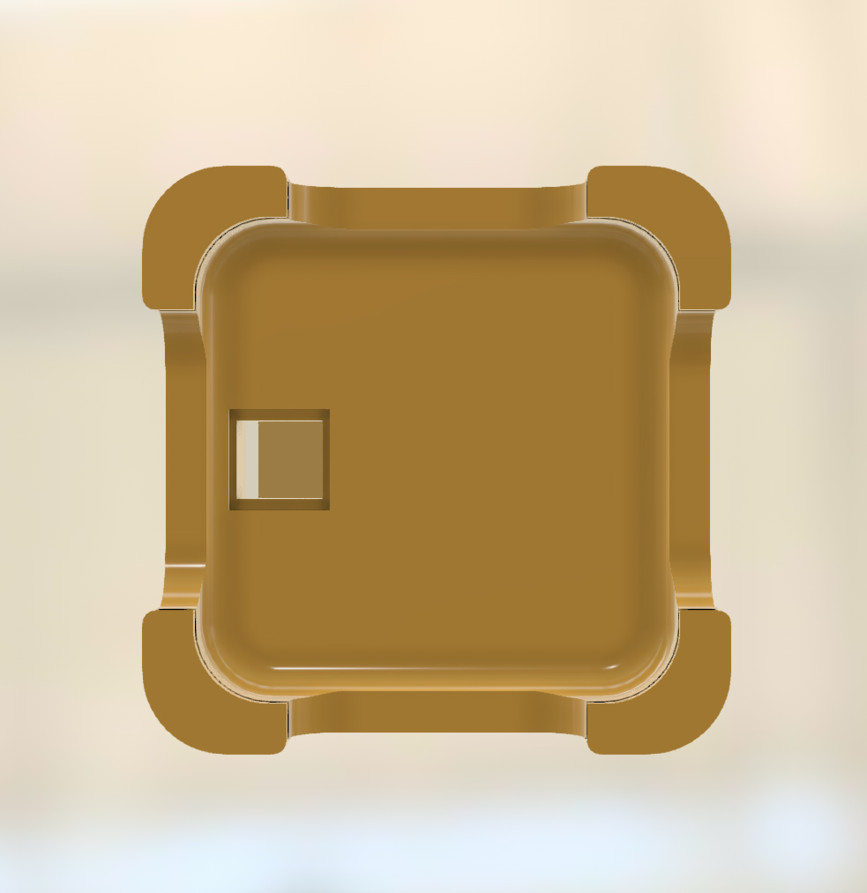

Result

Modeling Result
The LightMeCup prototype was designed in the Autodesk Fusion 360 modeling software, a cloud-based 3D developing platform that has the features of CAD, CAM and CAE tool. The rounded corners of the square shaped body were designed for minimalistic design while allowing for a comfortable grip. The overall design also considered how the object fits in various environment such as on a desk or next to a bed. The LightMeCup tumbler is made of three main parts of a cap, body and a support. The cap has a screw closure to prevent leaking of liquids in addition to a slider mechanism on the top of the cap for convenient and fast access to liquid. The body of the tumbler is designed to be printed with clear filament, which create a slightly opaque texture where liquid and light inside the tumbler is visible. The sensor part of the tumbler can be detached from the bottom for washing and charging. In addition, one magnet is installed in each corner of the tumbler to snap the sensor case in place. The rendered results of the model are shown in Table 3.

Output Result
The final prototype of LightMeCup was printed from an entry-level 3D printer and a low-cost PLA filament. During use, the LED light responds to the environmental sound received by the microphone sound sensor depending on the varying intensity of sound and rhythm. For example, the saturation of red light increases when the sensor detects treble sounds whereas the saturation of blue light increases with bass sound. Likewise, when the tumbler detects motion (acceleration and tilt), it overrides its respond to sound for a short period of time and displays a static white LED light. When motion is no longer detected, the tumbler returns to responding to environmental sound after a latency of approximately 1 second. The final 3d printed output of the prototype is shown in Table 4 and the power on and off view of the tumbler is shown in Fig. 2. The charging module takes approximately 30minutes to an hour to fully charge, and different color of light indicates the status of either charging or fully charged as shown in Fig. 3. After the tumbler is fully charged, it can be used continuously for approximately four to five hours.
Table 4. Final Output
Assembled | Dissembled
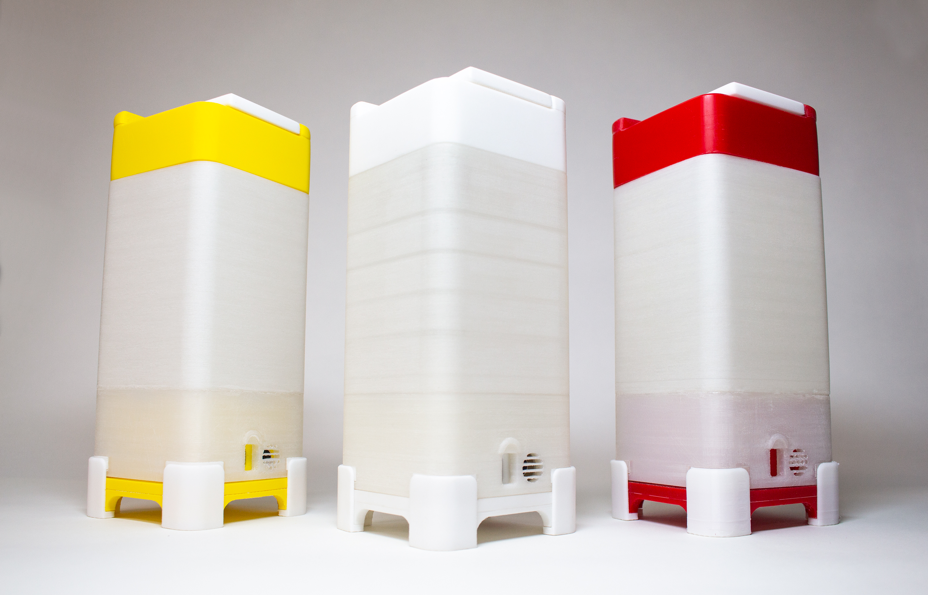 | 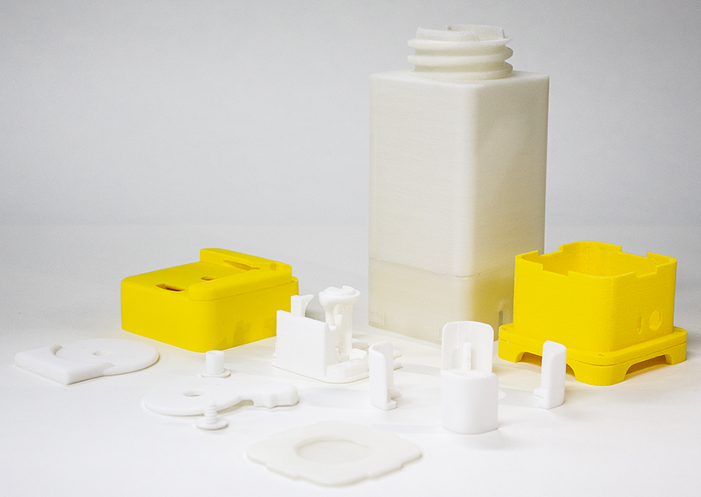
Cap | Support
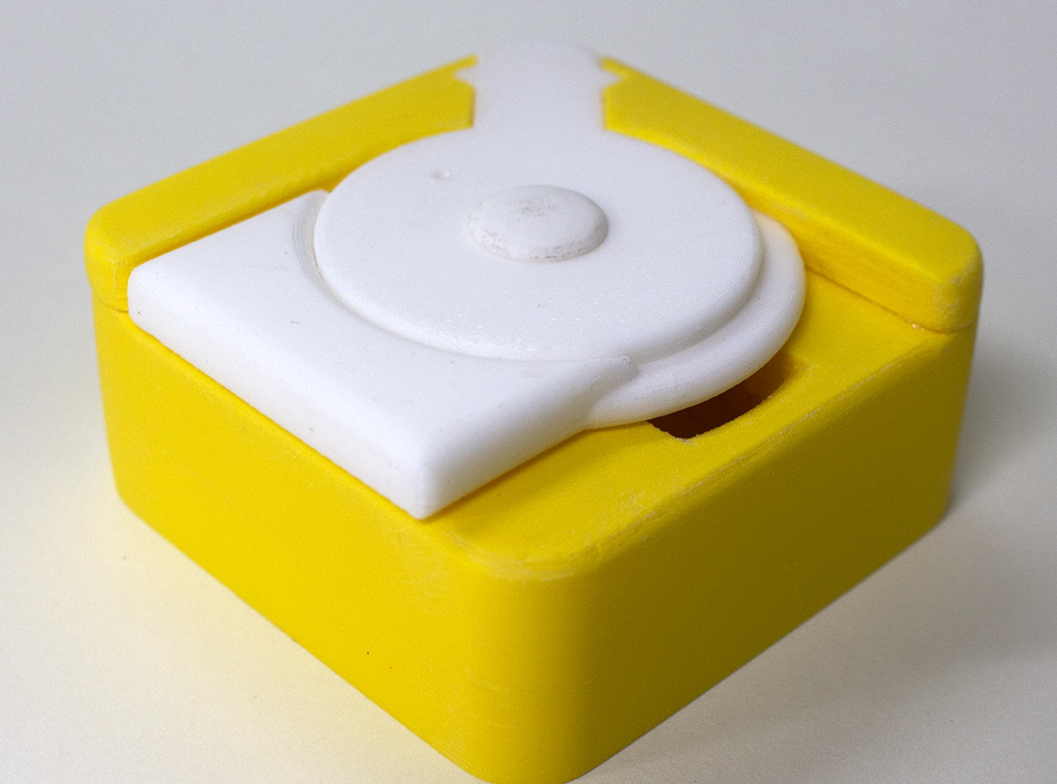 | 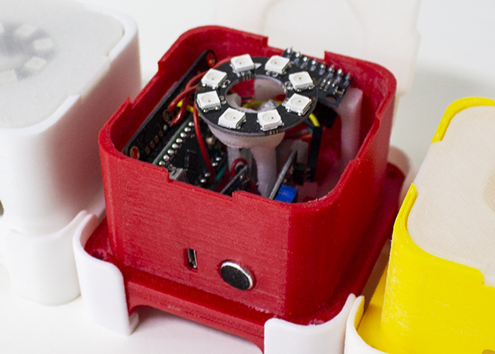

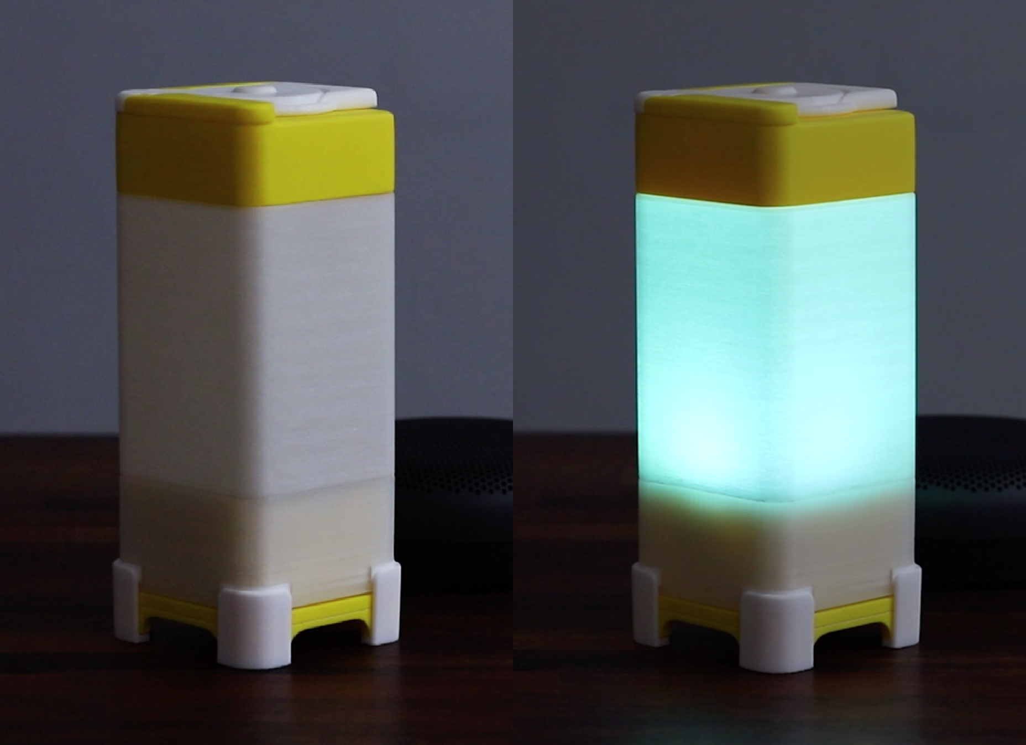
Figure 2 Power off (left) and on (right)
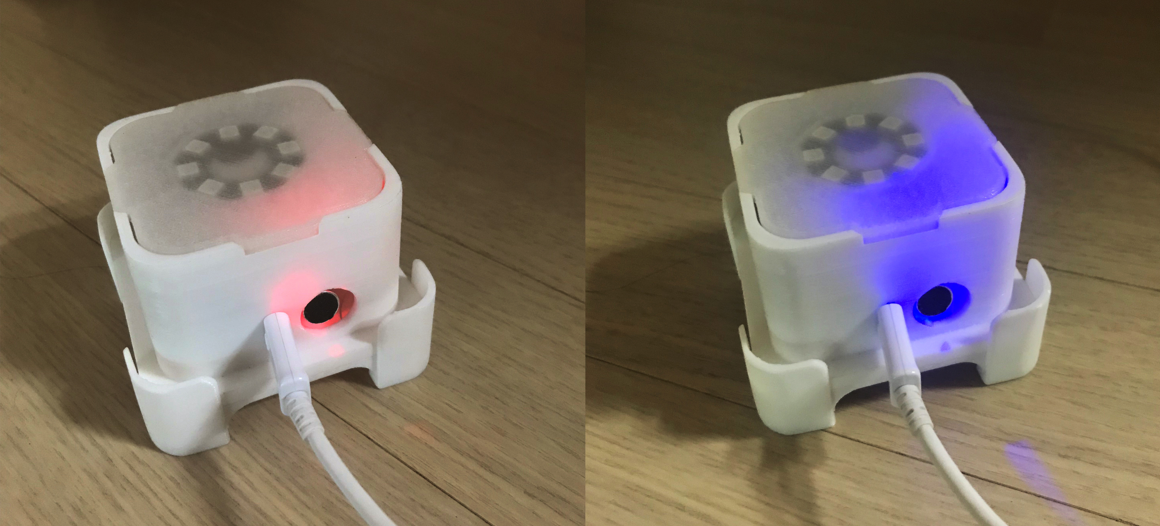
Figure 3 Two Charging Modes of charging (left) and fully charged (right)

Usability Testing Result
The LightMeCup was used and evaluated by 20 subjects who use lighting and tumbler daily as shown in Table 5. (item1: Do you feel self-conscious or psychologically insecure when using The LightMeCup? Item2: Is it a product you would want to use? Item3: Do you need to make difficult gestures or manipulations during use? Item4: Is it possible to use it easily with appropriate speed or efficiency? Item5: Can you use it anywhere in your place or time? Item6: Can you simplify the operation sequence without confusing on the operating process? Item7: Can you understand how intuitive it is? Item8: Is there any risk or incorrect operation? Item9: Is it simple to return when you make a mistake? Item10: Can the tumbler be used without discomfort? Item11: Can you open the lid with proper force? Item12: Is the size and grip of the tumbler comfortable and appropriate? Item13: Is it suitable in size and form to carry or store? Item14: Do you have a good impression on the color or form of The LightMeCup? Item15: Is the size and shape of the tumbler and lighting appropriate? Item16: Is cleaning and management simple? Item17: Does the lighting respond appropriately to the environmental sound? Item18: Is the range of LED light colors appropriate? Item19: Are the functions of lighting and tumbler adequate?

Table 5. Usability Testing Result
Factors | Items | M |  | SD
Equitable use | 1  2 | 4.3  4.1 | 4.2 | 0.4  0.7
Flexibility in use | 3  4  5 | 4.6  4.2  3.6 | 4.1 | 0.4  0.4  0.6
Simple & intuitive use | 6  7 | 4.4  4.6 | 4.5 | 0.4  0.4
Tolerance for error | 8  9 | 4.4  3.2 | 3.8 | 0.6  0.6
Low physical effort | 10  11 | 3.7  3.4 | 3.5 | 0.5  0.4
Size and space for approach and use | 12  13 | 3.3  3.8 | 3.6 | 0.6  0.6
Appearance and management | 14  15  16 | 4.1  4.1  4.6 | 4.2 | 0.7  0.8  0.4
Functionality | 17  18  19 | 4.8  4.1  4.2 | 4.0 | 0.4  0.7  0.6

The higher the average score of the result, the higher the satisfaction with product use. The overall average of the 8 areas was 3.8, with 5 areas rated 4.0 or higher and 3 areas less than 4.0. The highest score was 4.5, for 'Simple & intuitive use', followed by the score in the order of 'Functionality' and 'Appearance and management'. The LightMeCup developed in this study was evaluated as simple, easy to use and intuitive. The lowest score was 3.5 for 'Low physical effort' and 3.6 for 'Size and space for approach and use'. This is because the size of the product is slightly bigger than a standard tumbler due to the two-in-one function of lighting and tumbler, which makes it less familiar to the user. In addition, it is easy to find the position of the cup with the light in a dark environment, but it is judged that the score is low because there is a limitation in completely solving the process of opening the lid and drinking water.

Conclusion
This study developed a multi-sensory product using an entry-level 3D printer and low-cost filaments that functions as a tumbler type cup while being responsive to the environmental sound and motion of the cup through ambient lighting. The design considered user usability and convenience with three main detachable parts of a cap, body, and support (sensor case). With the final prototype of the LightMeCup, a survey for usability testing was performed in questionnaires by 20 subjects on a 5-point Likert scale. The product was evaluated as simple, easy to use and intuitive. However, users were less familiar with the bigger size of the product due to its two-in-one functionality of lighting and tumbler.
With the increasing accessibility of entry-level 3D printing technology, its application in product development and academic research is expected to become more active in the near future. The Project LightMeCup extends beyond the function of a standard tumbler, which consists of technology that responds with users’ physical motion and the environment. Our concept can be expanded in other uses and settings, including but are not limited to, a device that directly helps to regulate user’s emotion using light or sound reactive technology in response to the user’s affective state, which can be measured through physiological signals such as heart rate or skin temperature (Haag et al., 2004; Picard et al., 2001). In future research, the project aims to explore the ways in which devices can effectively and directly interact with the user both physically and emotionally.
Acknowledgement
This research was supported by Basic Science Research Program through the National Research Foundation of Korea(NRF) funded by the Ministry of Education, Science and Technology(NRF-2017R1D1A1B03036074).

Reference
- Desmet, P. M., & Hekkert, P. (2007). Framework of product experience. International journal of design, 1(1), 57-66.
- Haag, A., Goronzy, S., Schaich, P., & Williams, J. (2004, June). Emotion recognition using bio-sensors: First steps towards an automatic system. In Tutorial and research workshop on affective dialogue systems (pp. 36-48). Springer, Berlin, Heidelberg.
- Hassenzahl, M., Diefenbach, S., & Göritz, A. (2010). Needs, affect, and interactive products–Facets of user experience. Interacting with computers, 22(5), 353-362.
- Ikeda, K. (2005). Trends toward universal design in Japan. Fujitsu scientific and technical journal, 41(1), 31-37.
- Picard, R. W., Vyzas, E., & Healey, J. (2001). Toward machine emotional intelligence: Analysis of affective physiological state. IEEE transactions on pattern analysis and machine intelligence, 23(10), 1175-1191.
- Sutcliffe, A., & Hart, J. (2017). Analyzing the role of interactivity in user experience. International Journal of Human–Computer Interaction, 33(3), 229-240.

